Minimum System Requirements:

* Operating System: Windows 10 64-bit
* Processor: Quad-core Intel or AMD processor, 2.5 GHz or faster
* Memory: 8 GB RAM
* Graphics: NVIDIA GeForce 470 GTX or AMD Radeon 6870 HD series card or higher
* DirectX: Version 12
* Storage: 100 GB available space
* Additional Notes: SSD strongly recommended. Ensure your Windows software and all hardware drivers are up to date.

Recommended System Requirements:

* Operating System: Windows 10 64-bit
* Processor: Quad-core Intel or AMD, 2.5 GHz or faster
* Memory: 32 GB RAM
* Graphics: NVIDIA GeForce 1080 GTX or AMD Radeon RX 580 series card or higher
* DirectX: Version 12
* Storage: 200 GB available space
* Additional Notes: SSD strongly recommended for optimal performance. For use of all features (like Nanite), a DirectX12 and Ray Tracing compatible video card is required.

**Note :** Unreal Nanite require DirectX 12. But DirectX 12 might cause an issue with lower specification computer.

**Tutorial Reference:**

**https://docs.unrealengine.com/5.1/en-US/**

**https://www.youtube.com/watch?v=Z9zEEY7dGaM&ab_channel=MattAspland**

**https://www.youtube.com/watch?v=qbgDaRo312k&ab_channel=MattAspland**

[**How to Create a Game in Unreal Engine 5 - UE5 Beginner Tutorial**](https://www.youtube.com/watch?v=ITCWa3oLNAQ&t=881s&ab_channel=UnrealSensei)

[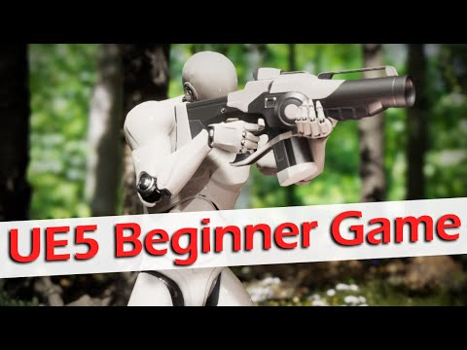](https://www.youtube.com/watch?v=ITCWa3oLNAQ&t=881s&ab_channel=UnrealSensei)

[**Unreal Engine 5 | Blueprint For Beginners**](https://www.youtube.com/watch?v=bY6Nl-OEhSo&t=4362s&ab_channel=SmartPoly)

[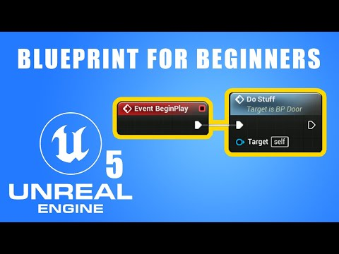](https://www.youtube.com/watch?v=bY6Nl-OEhSo&t=4362s&ab_channel=SmartPoly)

**Some key features of UE5 include:**

1. Nanite Virtualized Geometry: This new technology allows for the rendering of highly detailed and complex environments without compromising performance. It enables developers to import film-quality assets and generate realistic scenes without manual optimization.
2. Lumen: A real-time global illumination system that reacts to changes in lighting conditions, Lumen provides realistic and dynamic lighting for scenes. This eliminates the need for baking lightmaps and allows for the creation of more lifelike environments.
3. World Partition: This feature allows for the automatic streaming of game worlds, making it easier for developers to create vast, open-world experiences. It manages the loading and unloading of level data based on the player's location, improving performance and reducing load times.
4. Chaos Physics and Chaos Destruction: These systems enable realistic physics-based interactions and destruction in the game environment, providing more immersion and allowing for emergent gameplay.
5. MetaSounds: A new audio system providing more control and flexibility for sound designers, enabling the creation of intricate and dynamic soundscapes.

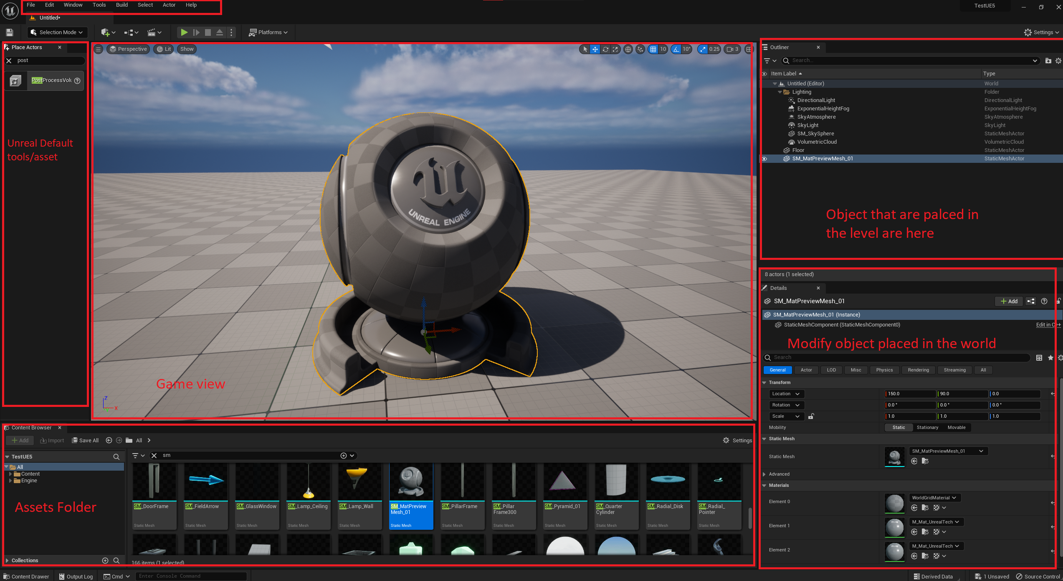

**Materials**

**We can create materials by right clicking inside content browser folder**

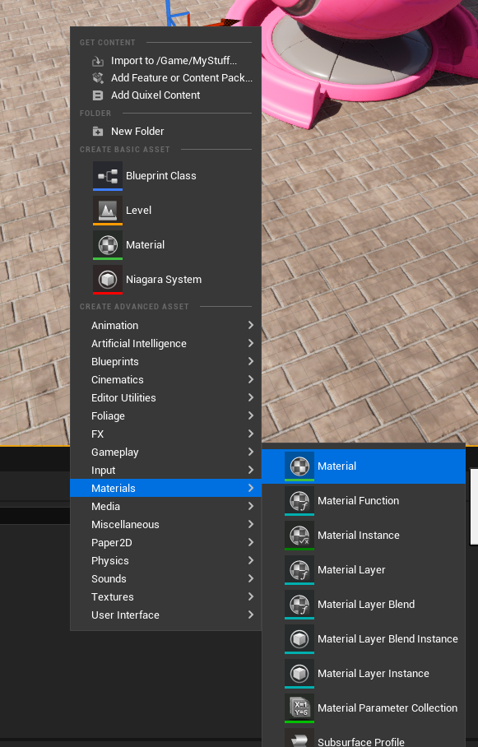

It will create asset which we can open in material editor and start creating materials. Its better to create instance of the material that we create so that we don’t override the main material. We can do this by right clicking on Material asset that we created.

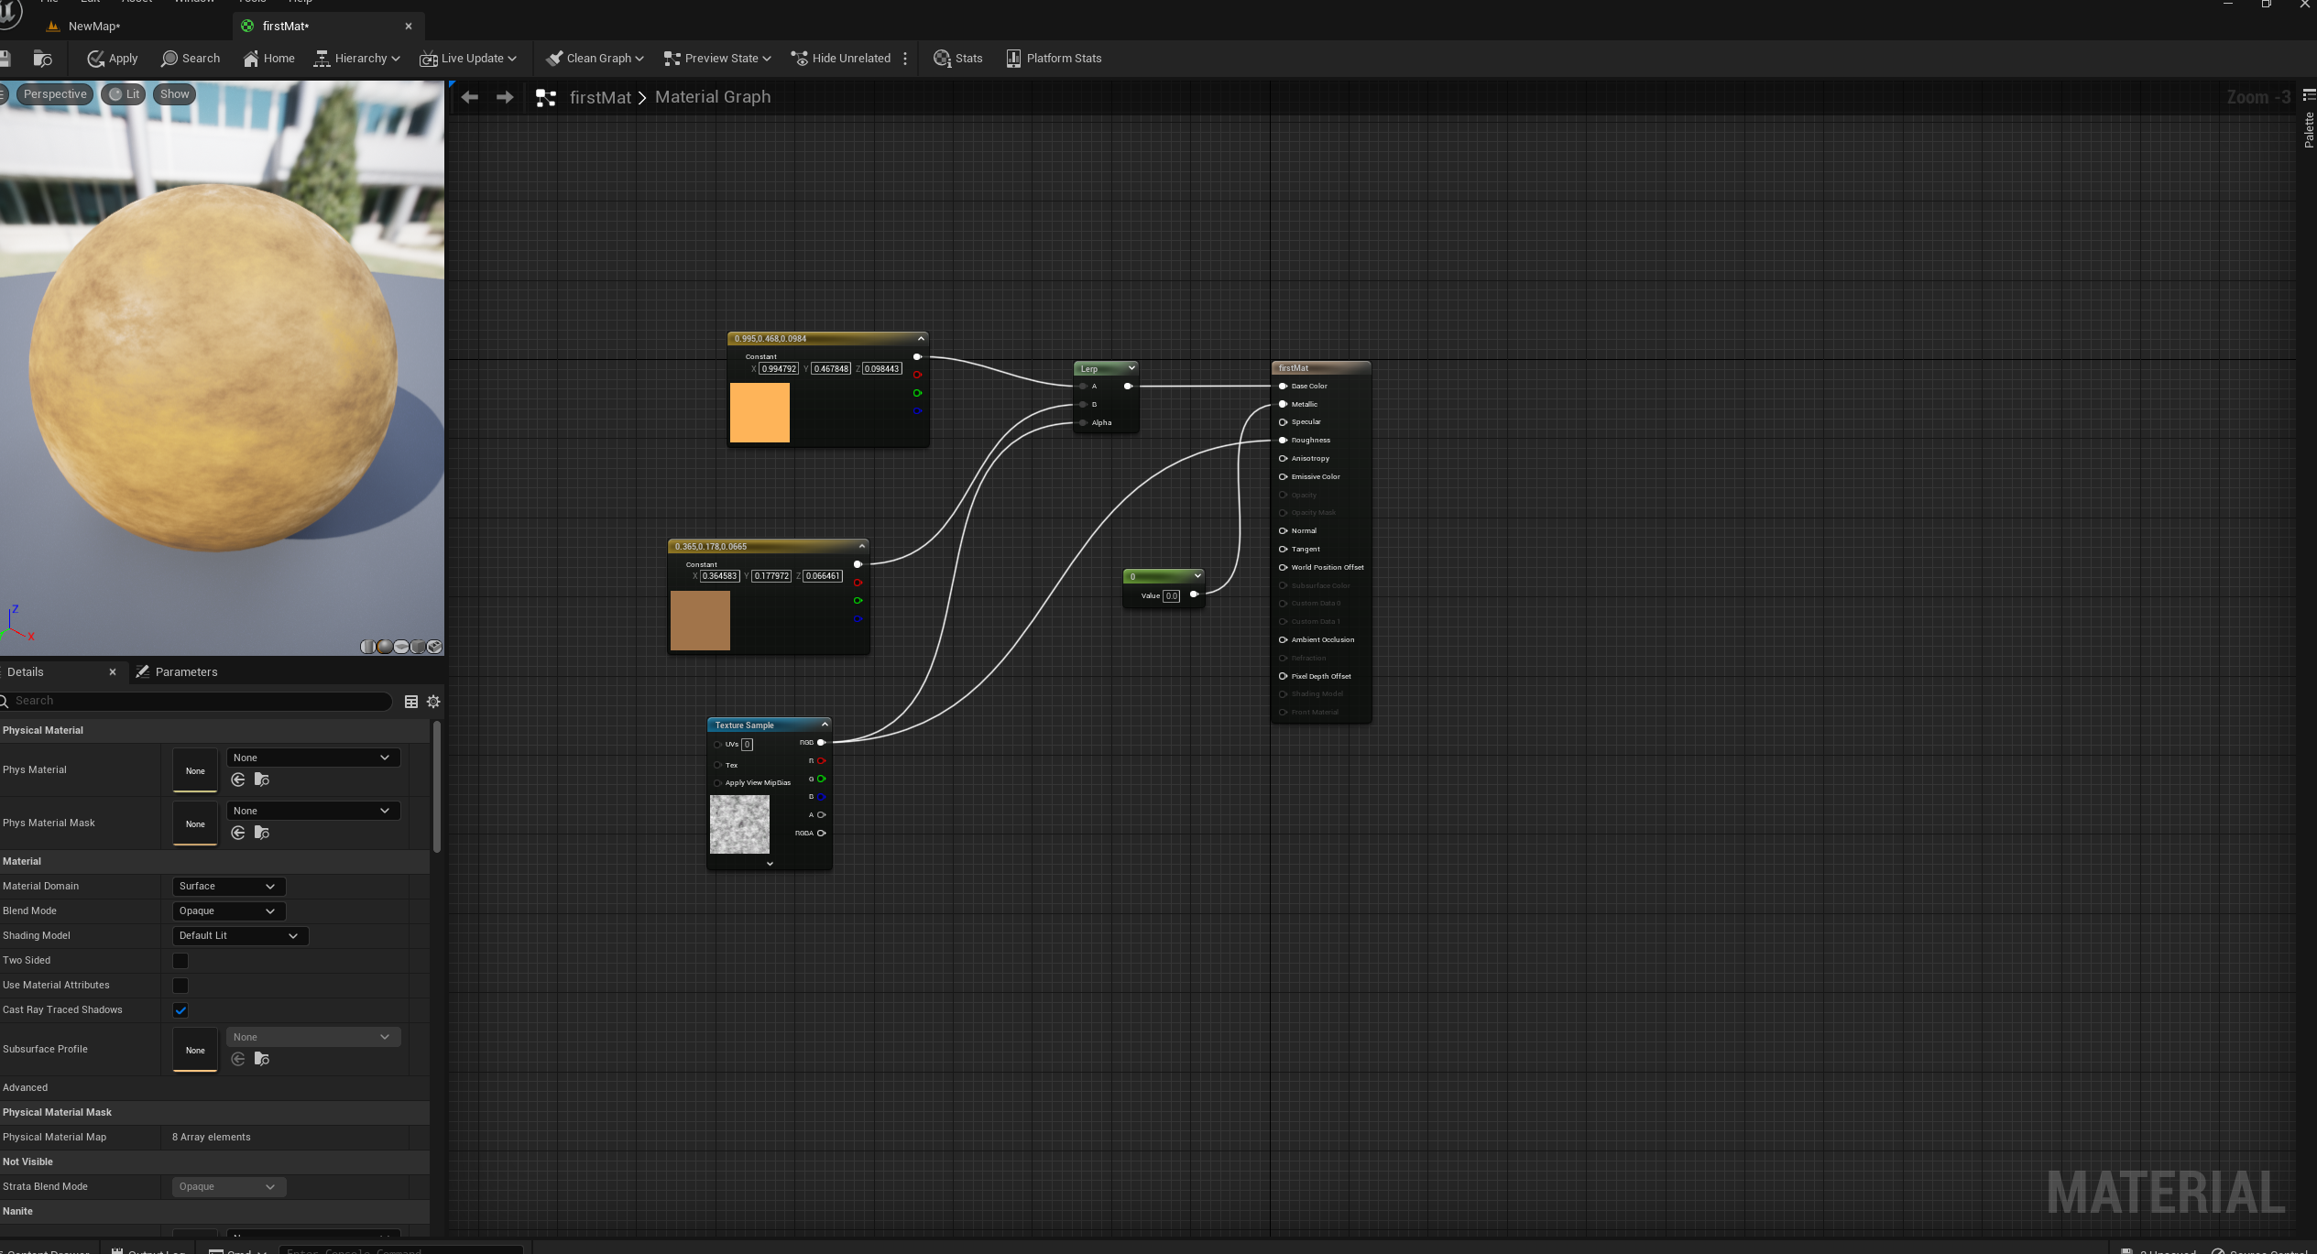

After finish we can drag and drop it on the object in the level editor/ scene view

**Light**

In Unreal Engine 5 there are several types of lights that you can use to create realistic and visually appealing scenes. Each light type serves a different purpose and has its own unique characteristics. Here are the primary light types available in UE5:

1. Directional Light: This type of light simulates sunlight and illuminates the entire scene from a specific direction, without any attenuation. Directional lights are ideal for outdoor environments, where you need to simulate the sun or moon. They cast shadows and interact with the Lumen global illumination system for realistic lighting.
2. 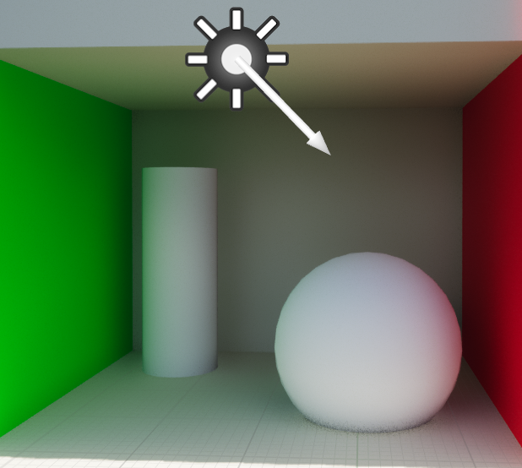
3. Point Light: Point lights emit light in all directions from a single point in space. They have a limited range and attenuation, which means the light intensity decreases with distance from the source. Point lights are great for simulating small light sources like lamps, candles, or lightbulbs. They can cast shadows and contribute to Lumen global illumination.
4. 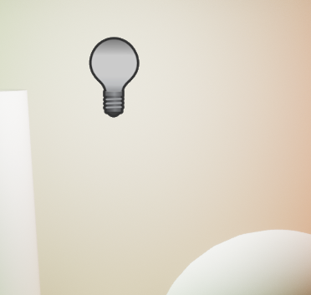
5. Spotlight: Spotlights emit a cone of light in a specific direction. They have adjustable inner and outer angles, which control the falloff of light intensity at the edge of the cone. Spotlights are useful for creating focused or directional lighting effects, such as a flashlight or a stage light. They can cast shadows and contribute to Lumen global illumination.
6. 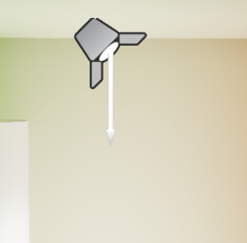
7. Rectangular Light: Rectangular lights emit light from a planar rectangular surface. They provide more realistic area lighting, simulating light sources like TV screens, windows, or large light panels. Rectangular lights generate soft shadows and contribute to Lumen global illumination, making them ideal for architectural visualization and indoor scenes.
8. 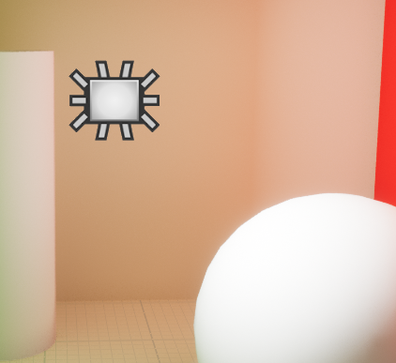
9. Sky Light: Sky lights are used to simulate ambient lighting from the sky. They capture the distant parts of the scene (or a custom HDRI image) and generate indirect lighting based on that information. Sky lights help create a more natural and realistic lighting environment by filling in shadows and providing overall illumination. They work together with the Lumen global illumination system to create realistic indirect lighting.
10. 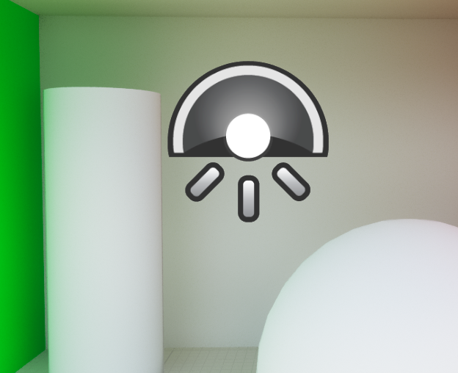
11. Emissive Materials: While not technically a light type, emissive materials can contribute to scene lighting in UE5. You can create materials that emit light by using the Emissive input in the material editor. Emissive materials can be used to simulate glowing objects, like neon signs, LEDs, or computer screens. In UE5, emissive materials can also contribute to Lumen global illumination, allowing them to cast light on nearby surfaces.
12. 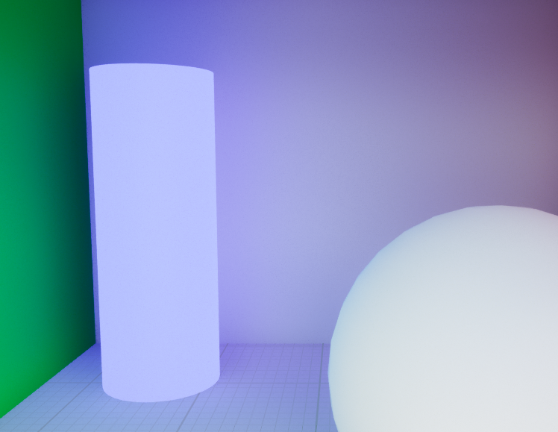

Remember to keep in mind performance considerations when using multiple lights and their respective settings, as they can impact performance and overall scene complexity.

**Lumin**

**Without Lumin**

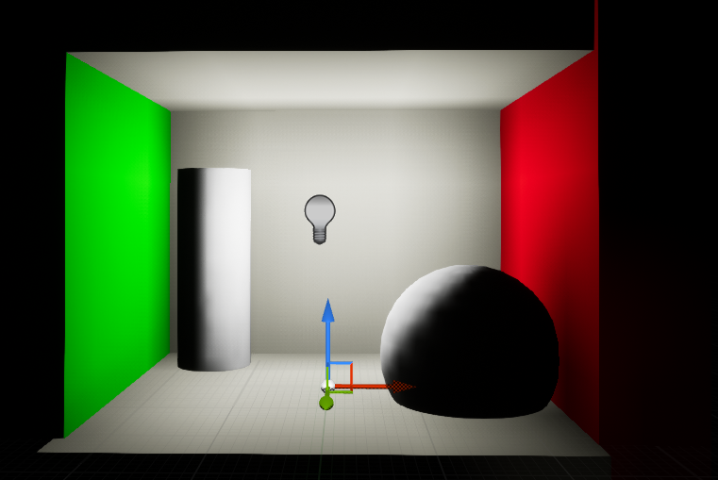

With lumin

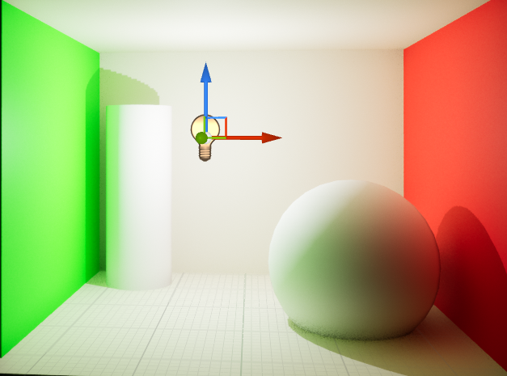

Its possible to move project content to another project by using migration.

Landscape

We can create landscape by switching landscapes mode

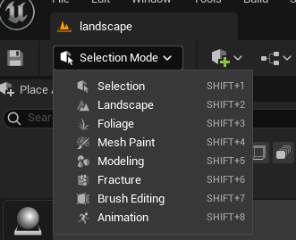

Or By pressing Shift +2. This will ask us to give parameters for our landscape. We can just use the default settings to create our landscape.

Landscape Materials

There are a lot of node to be use to create a very good material. Following is a very simple landscape material

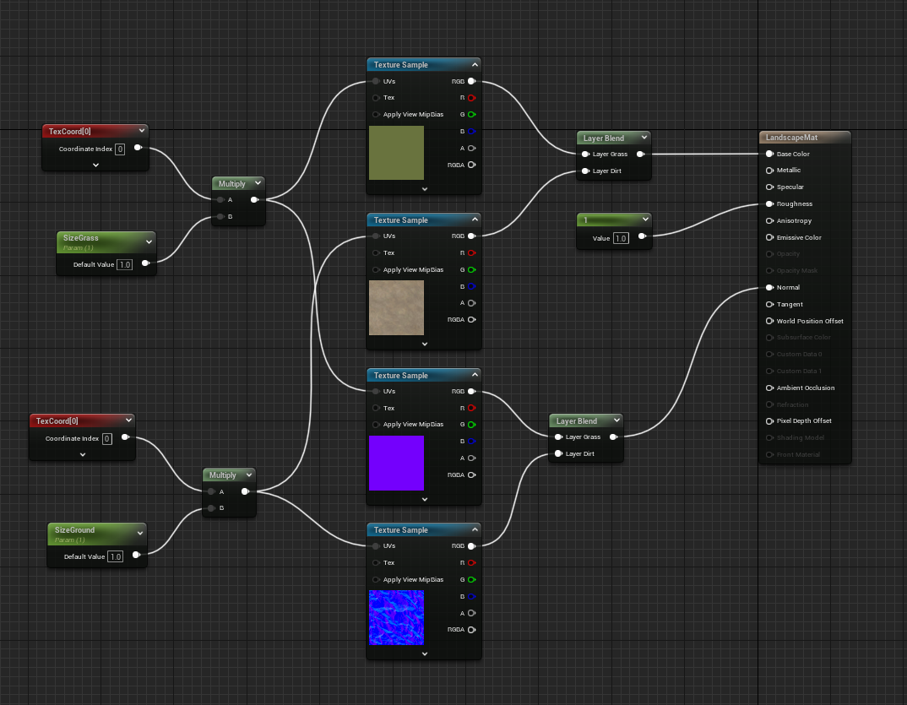

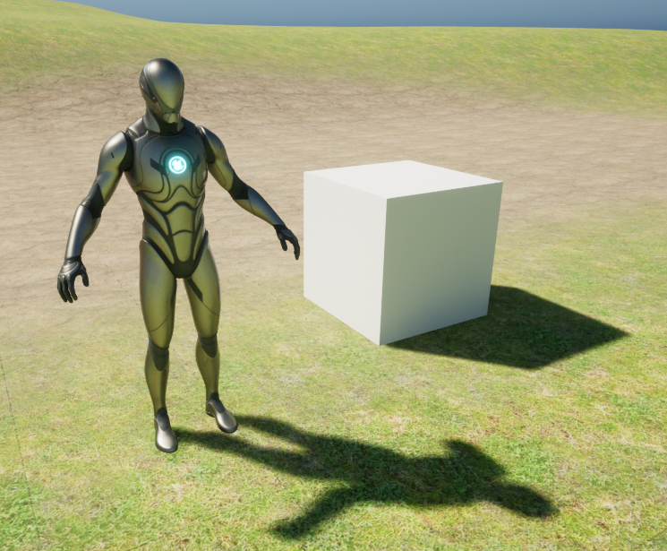

Marketplace

We can access UE4/UE5 marketplace by opening Epic Games installer then clicking on Unreal Engine button and then opening Marketplace tab.

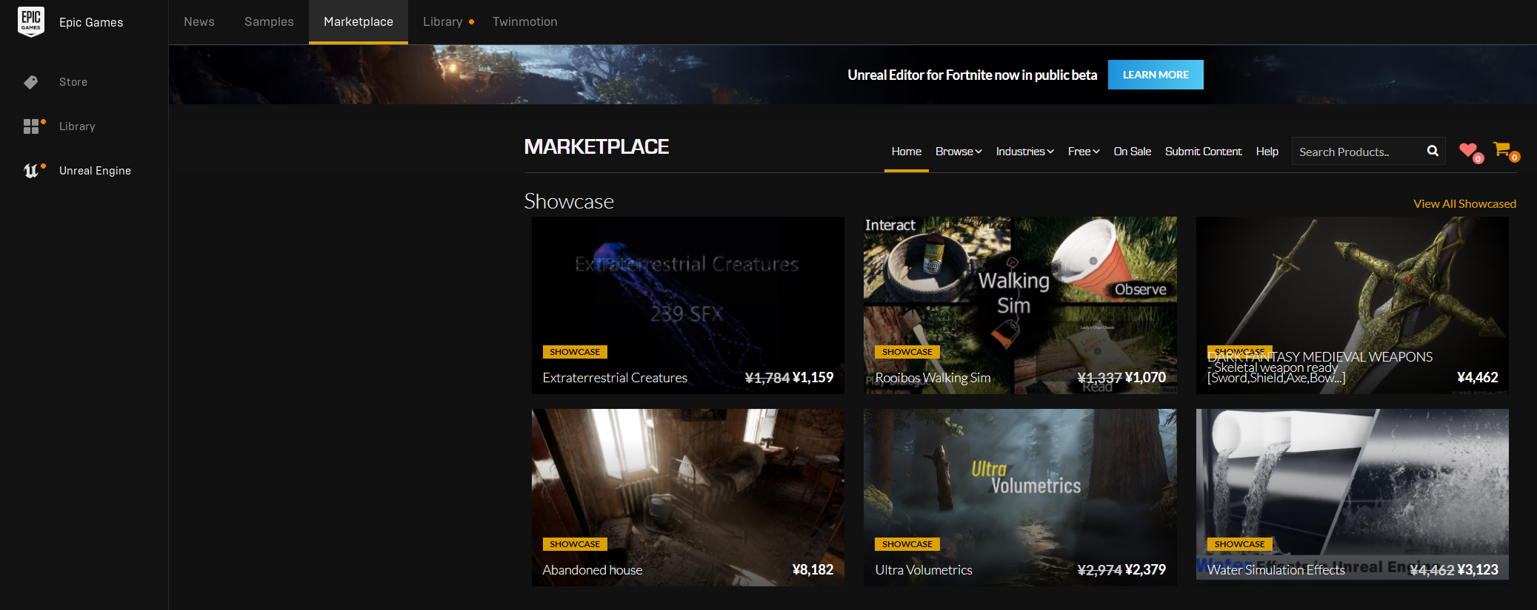

When downloading an asset, we need to be careful about if the version of Unreal engine support it or not.

Common Error When using UE5

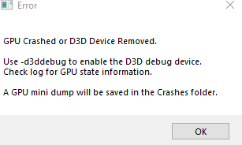

Solution 1:

Open Project folder. Go to Config Folder and Edit Default Engine File.

change DefaultGraphicsRHI=DefaultGraphicsRHI_DX12 to DefaultGraphicsRHI=DefaultGraphicsRHI_DX1

**Quixel Bridge with Unreal Engine / Megascan**

Quixel Megascans is a massive online library of 3D assets that includes thousands of high-quality, photorealistic 3D scans of real-world objects, materials, and environments. These scans are often used in game development, film production, and other forms of digital media to create visually stunning and realistic environments and objects.

Quixel Bridge: This is a content management tool that lets you easily browse, download, and export assets to various 3D and game development software, including Unreal Engine.

We can access it from UE5 editor by clicking add button on top left corner .

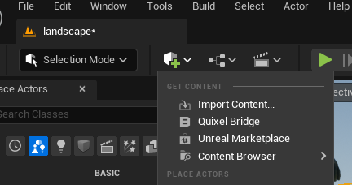

If it is not available, then we need to install it from the Epic game's installer.

Unreal Engine > Library then search for Quixel bridge asset/package

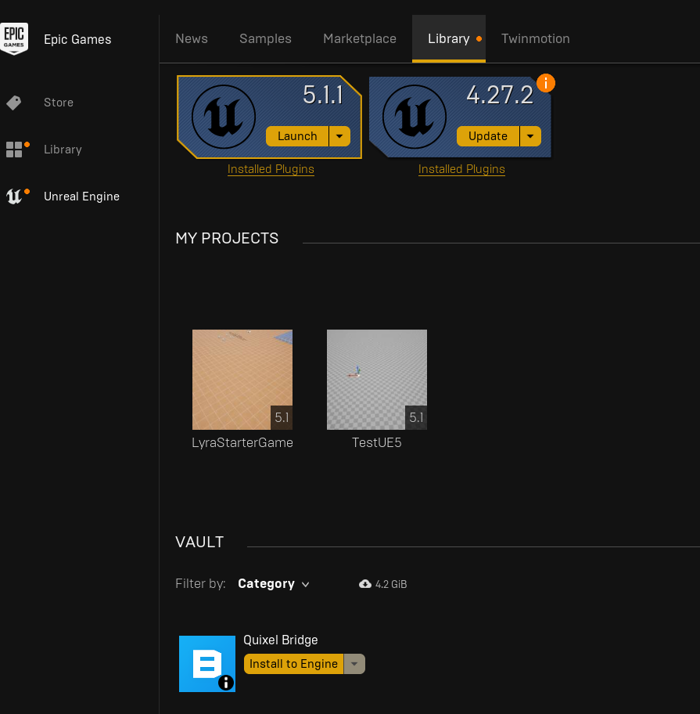

Inside Editor we can drag and drop asset like this

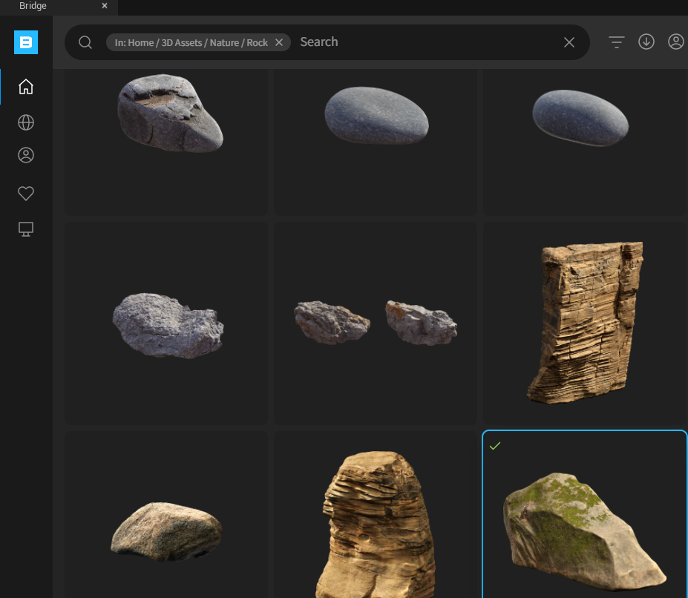

**Foliage Mode:**

Unreal Engine 5's Foliage mode allows designers to paint large, realistic landscapes with various foliage types. This includes trees, grass, and flowers, enhancing environmental realism. It includes tools for painting, erasing, selecting, and reapplying foliage, with dynamic LOD systems for optimized performance, enhancing the creation of rich, natural environments. We can switch to foliage mode and then place 3 mesh to foliage section. After that click on the check box on top of foliage icon and paint on the landscape.

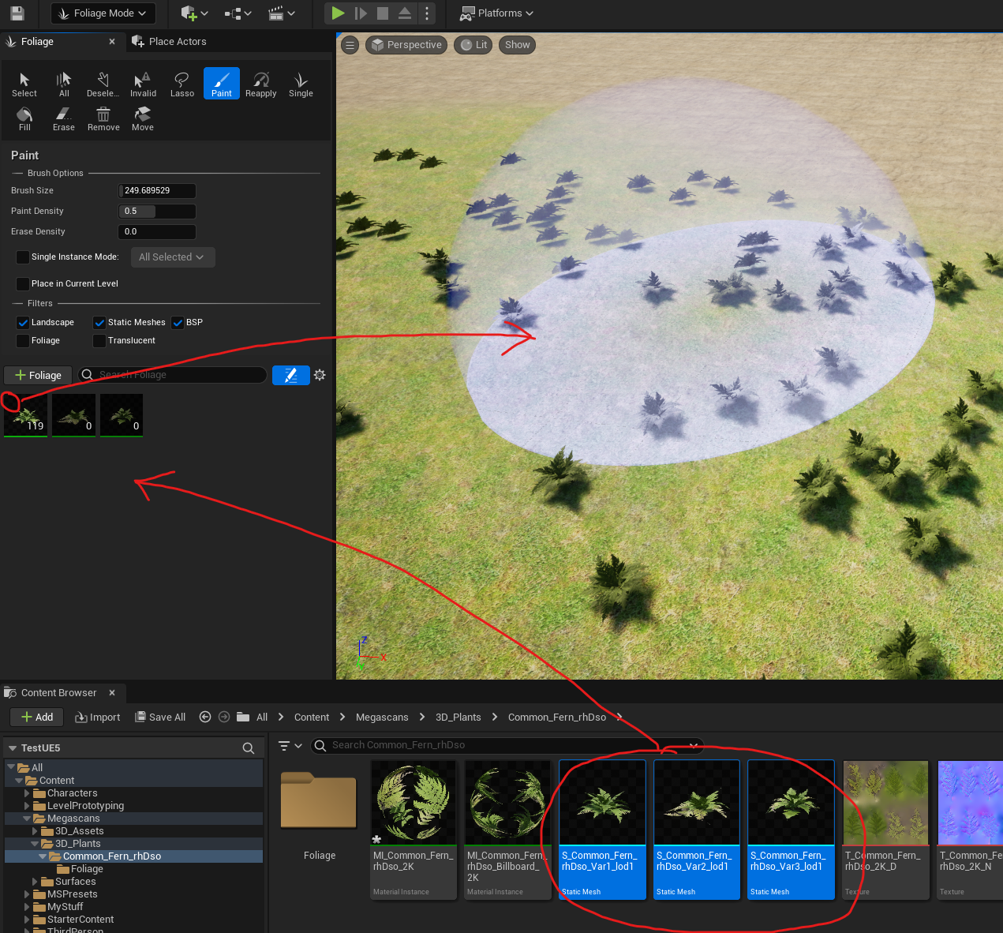

**Nanite**

Unreal Engine Marketplace nanite sample could not be tested because the minimum requirement does not match. It requires 32 GB RAM at minimum.

The following picture each small color represents 1 triangle.

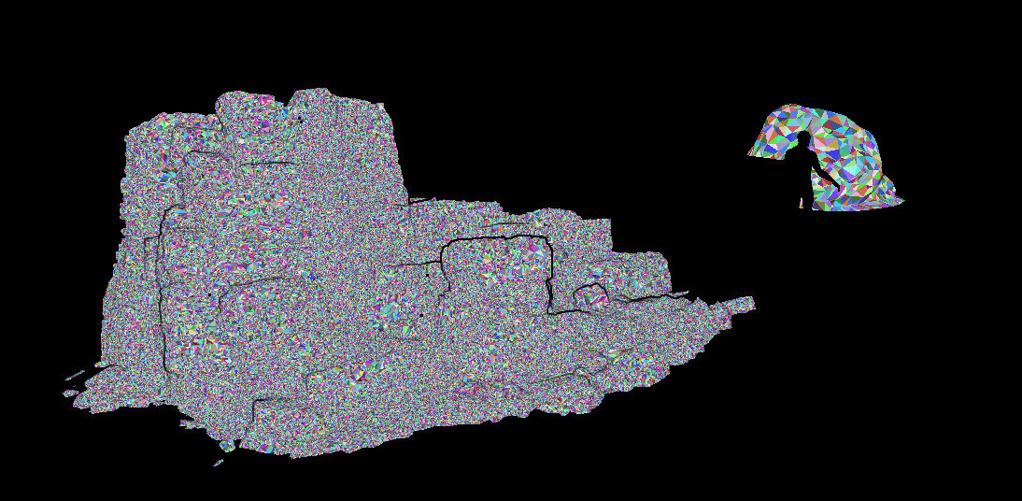

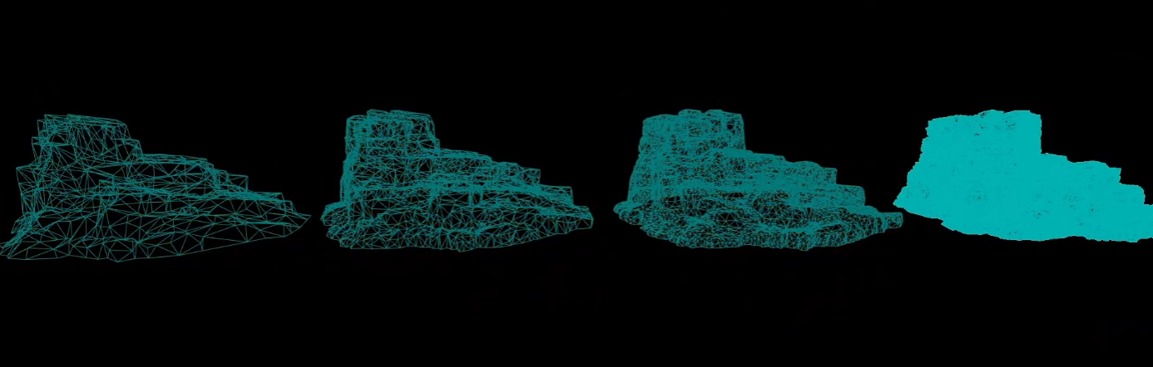

From left to right (low, medium, high, nanite) quality mesh.

**Blueprints(coding system):**

Blueprints in Unreal Engine 5 (UE5) are visual scripting tools that empower developers to create game logic without traditional programming. They enable the design of interactive actions, AI behavior, and more, using nodes and connections representing game events, variables, and functions. Blueprints promote easy prototyping and testing within UE5.

Following is a picture of a sample of UE5 blueprint

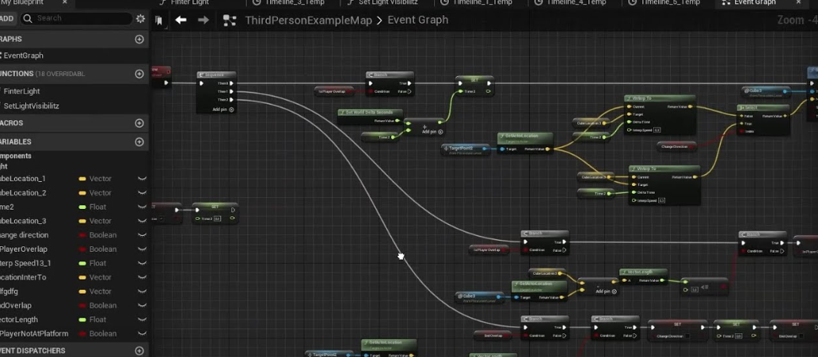

Since there are few different types of blueprint in UE5. Followings are some of the important ones

* Actor Blueprints: These are used to create individual objects in the game world that have behavior, such as a door that opens and closes or an item that the player can pick up.
* Pawn Blueprints: These are a type of Actor Blueprint specifically designed for objects that can be controlled by a player or AI, such as a character or vehicle.
* Character Blueprints: These are a specific type of Pawn Blueprint that includes built-in support for character movement and animation.
* PlayerController Blueprints: These are used to interpret player input and control Pawns.
* GameMode Blueprints: These are used to control the rules of the game, such as the win/lose conditions, which PlayerController to use, and other game-specific parameters.
* HUD Blueprints: These are used to create the heads-up display, or on-screen interface elements.
* Widget Blueprints: These are used for creating complex user interface layouts.
* Level Blueprints: These are associated with individual levels or maps and can control level-specific behavior.
* Animation Blueprints: These are used to control complex animation behavior based on a variety of inputs and conditions.
* Blueprint Interfaces: These are used to define functions that can be called on different types of Blueprints, allowing them to communicate with each other in a standardized way.
* Blueprint Macros: These are a way of creating reusable chunks of Blueprint script that can be used in multiple different Blueprints.
* Blueprint Function Libraries: These are collections of related functions that can be used in any Blueprint.
* Game Session: Game Session is responsible for managing multiplayer game sessions. This includes creating, starting, and ending game sessions, as well as handling player matchmaking. Game Session exists on the server only and is created before anything else when a new game starts. In a multiplayer game, the Game Session can be used to enforce game rules, manage player connections, and other high-level tasks.
* Game State: Game State is used to keep track of game-wide properties and states, such as the overall game score, time remaining in the game, or the current phase or state of the game (for example, whether the game is in progress, paused, or ended). Game State exists on both the server and all clients and is replicated across all machines involved in the game. This allows all players to have access to the same game-wide information.
* Player State: Player State is used to track information specific to each player, such as their individual score, health, or other player-specific properties. Like Game State, Player State exists on the server and all clients, and is replicated across all machines. This allows each player to have access to their own information, as well as information about other players. If a player leaves and rejoins the game, the Player State can be used to restore their status.

**Input System:**

**Blueprint coding:**

**Animation blueprint :**